Culinary Stop in Montreal

(The Battle of Neighborhoods, Coursera Capstone Project)

**By Adil Ezzaam**

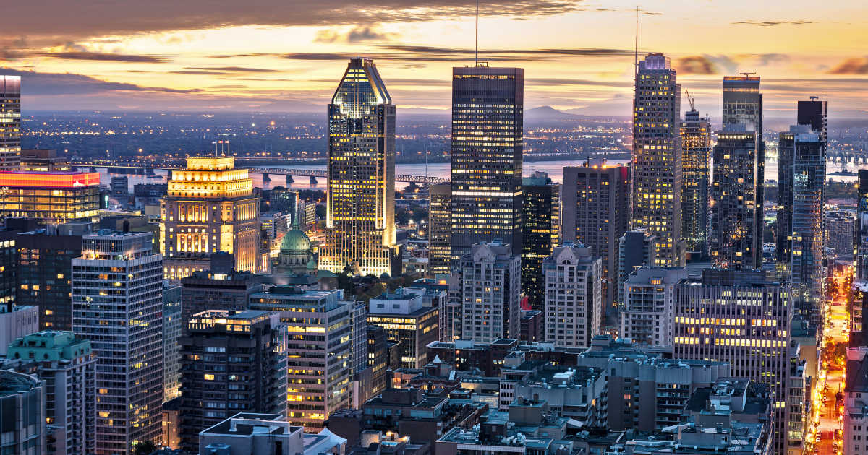

Introduction

Montreal, the 2nd most populated city in Canada is the realm of diversity. Known for his events occurring all year long, the city offers activities of all kinds, many are known internationally. Beside of his entertainments options, Montreal is the nest of opportunities, also the 2nd largest economy in Canada by having several type of industries. When we talk about diversity, we can also question the food. The city hides restaurants and bars that offers a variety of meals at different price range. Depending on the location, those venues might be open early and close late at night. While the most common places are located in downtown area, what about if we had to open a restaurant that could benefit from the neighborhood demand? Opening a restaurant might sound like a dream but it requires some expertise on where it should be located.

Problem & Approach

As my capstone project, the objective will be to find what the best locations to open a restaurant are. We will also identify what type of restaurants we should open for a given location. For all those questions, data science brings a significant amount of tools which we will combine with machine learning. We will require location data. To obtain those, we will use **Beautiful Soup** web scrappingtechnique on the Wikipedia page of Montreal boroughs. Then, we will utilize a **Geocoder API** such as the one from **Google Maps** to obtain and assign the latitude and longitude of those boroughs. The data of the venues will be gathered with the **Foursquare API**. To limit the amount of data, we will keep a limit of 10 venues per boroughs. The analytics will be done with **K-means** clustering algorithm. Everything will be presented on a map generated with **Folium**. A few other libraries will be used such as **Panda** for dataframe manipulation.

Target Audience

The field of catering requires a lot of dedication. Often an ambitious chef will be the owner of his place but this research is also dedicated to the investors and individuals who are willing to make business. While Montreal has a lot of restaurants (nearly 26 restaurants per 10,000 people), this research will find the most optimal places.